NY 2019 Measles Outbreak

Visualization Critique

# Overview

This visualization is with regard to the measles outbreak in New York from 2019. In this year there were registered 1250 cases of measles in the whole USA, ever since the disease’s eradication in 2000. Out of that number of cases half of them were registered in NYC. This Visualization example aimed to provide a better understand of the outbreak’s evolution with regard to the number of cases by neighbourhood, age, vaccination status and date. In this case we will try to alter the visualizations which offered an overview over the vaccination status and the date information in order to divert the opinion of the public in the other direction.

# Explanation of data

Two CSVs are used in this case. The first one contains information about the vaccination status of the patients in NYC from the start date of the outbreak, to the end of it along with the total number of patients for each category of the statuses: Unvaccinated, One Prior MRR, Two Prior MMR, Unknown prior MRR. The other CSV contains information about the total number of cases for each month for the entire time of the outbreak starting from Sep 2018 up to Aug 2019, along with the total number of cases in order to have a scale on which to measure the gravity of each month.

# Explanation of visualization techniques:

The first visualization technique used is the one with vaccination status; the author chose to represent the data as a horizontal bar chart in which for each type of vaccination status, its percent out of the total number of cases is shown, in order to display the importance of the vaccination.

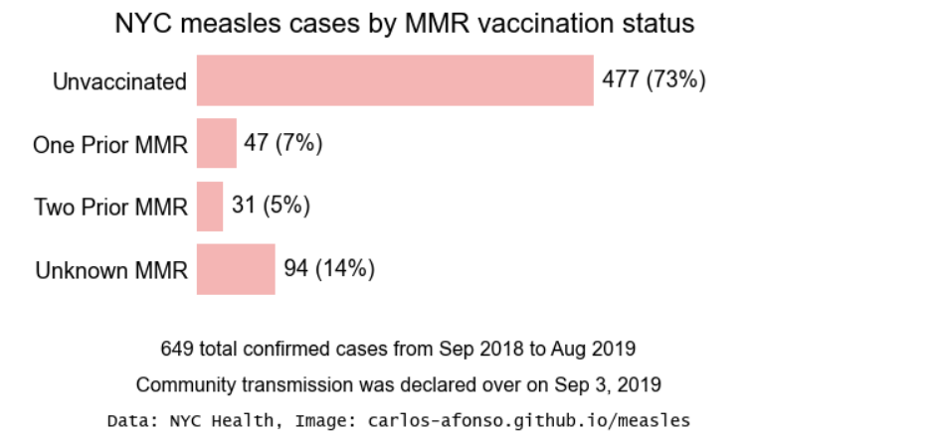

The second visualization technique presented is about the development of the outbreak on its whole duration, from Sep 2018 to Aug 2019. A bar chart is presented with the total number of cases per each month, along with the total number of cases overall in order to have an idea of the distribution of cases in time.

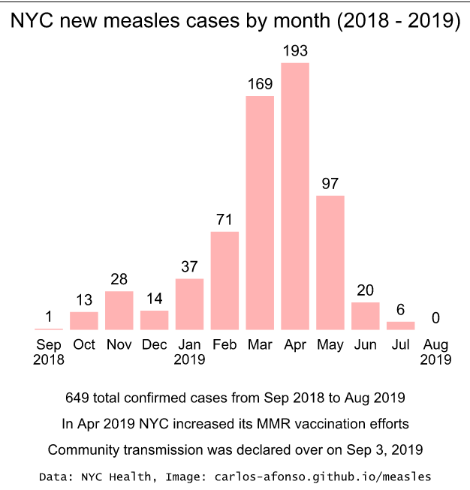

# Effectiveness & Integrity of the visualization

For the first case the visualization achieves its objective quite well since it shows for each category the total number of cases, also providing the whole total along with the source of the data, so anyone can check if the numbers are real. Displaying the numbers is done in order to correctly display the reality of the outbreak, ruling out any exaggeration or suspicion of hiding information from the public. In the second case, the spike describes the peak of the outbreak, also the moment when the NYC Health Dept. took strong measures in order to increase the vaccination number, which indeed was efficient since we can see that in the following four months the outbreak was stopped. Which proves that the visualization is indeed efficient and shows the reality. In both cases, the integrity is provided by mentioning the scale of the data, the source and its meaning. So biases can be ruled out by checking if the data source is real and from official sources.

# Design

The design is quite well done in both cases since there were two iterations of the visualization:

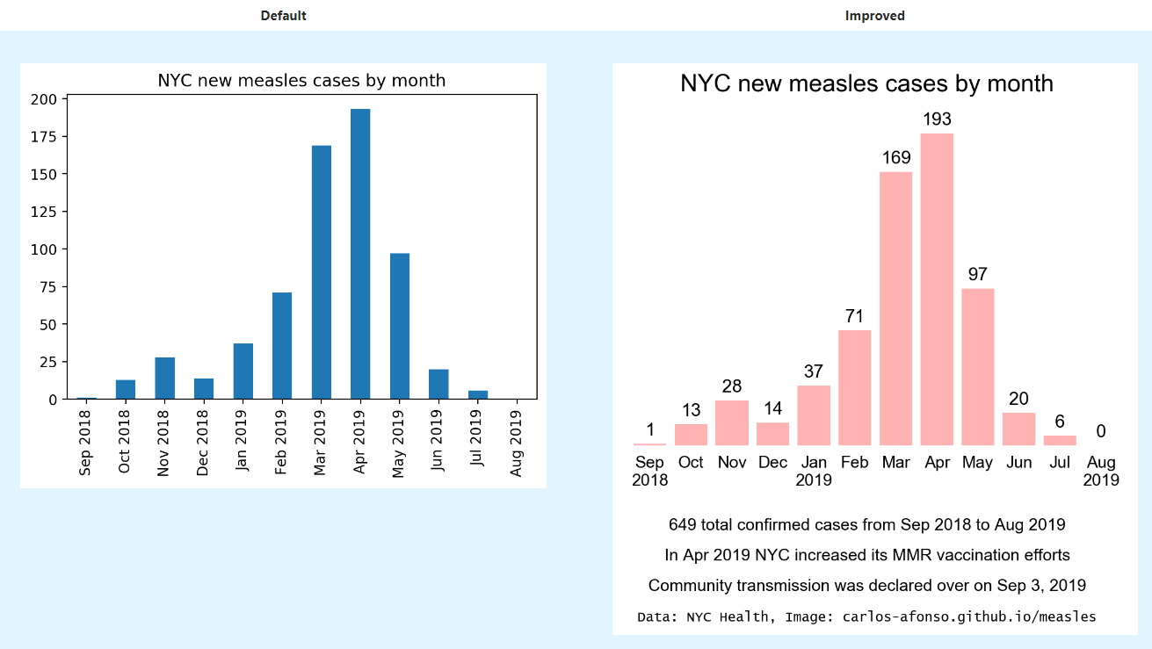

* the number of cases was added on each bar to provide better insight
* the source was added
* the total number cases was added
* the y axis was replaced by the addition of the first mentioned improvement
* the month for each bar was better arranged

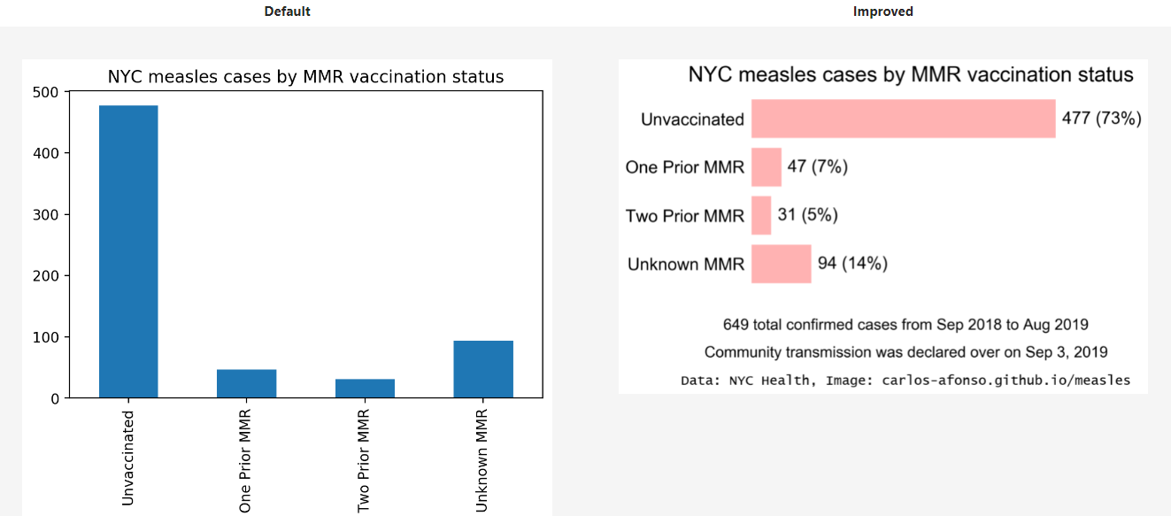

* switching the perspective for better readability
* adding the exact number of cases with their percent instead of y axis for better insight
* adding the source and the total number of cases

# Manipulations

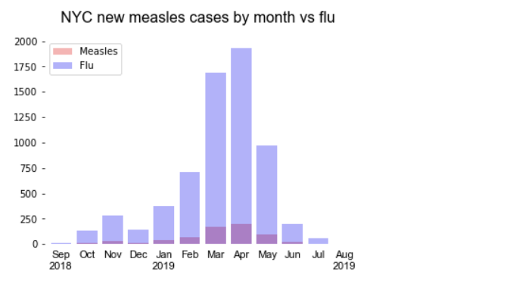

For this first case, in order to lower the public’s opinion regarding the gravity of the outbreak, we can simply remove the sources of the data, add some exaggerated false data with regard to the flu cases for the same period, remove the exact numbers in order to be hard to observe that the flue cases are exactly 10x times larger than the measles and that’s it. Now the measles looks like it has way lower gravity than the measles.